
Sightseeing tour through London

1. Scan the QR-code.
2. Zoom in to London.
3. Start at the red pin!

Start of our sightseeing tour is the _________________________.
The next stop is the _________________.
Here you can look at the crown jewels.
We go shopping on stop No. 3:
________________________________.
Now we relax in ____________________.
The next stop is _____________________ on __________________________.
Then we go to the ___________________
_________________________.
Here we can see the famous ________________________, too.
We take a boat on the river Thames and come to the ______________________.
Our next sight is ________________________________.
Here the queen got her crown.
Now we take a look at the _______________________________,
where they play football and rugby.
The next stop is the very high skyscraper ________________________.
The fans of Harry Potter visit ________________________________ and platform 9¾.
The sightseeing tour ends at the queens home: ____________________________.

4. Fill the gaps.
5. Stick in the correct pictures.
Pictures you need:
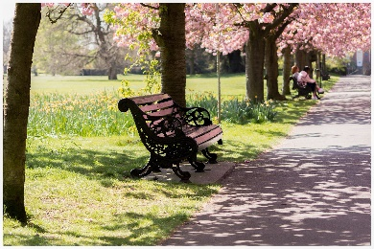 | 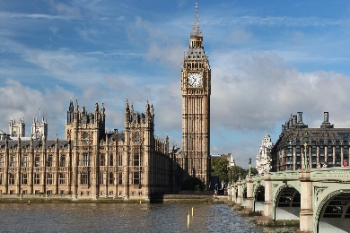 | 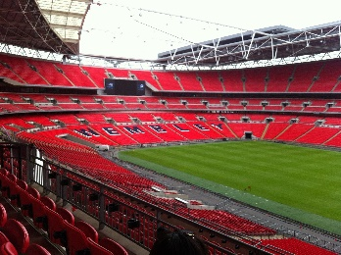
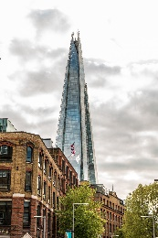 | 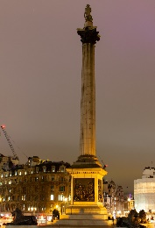 | 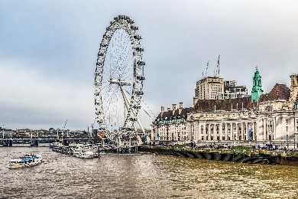
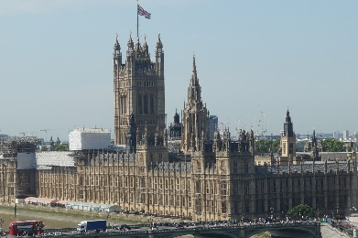 | 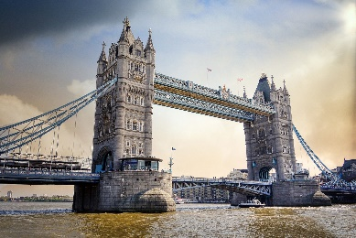 | 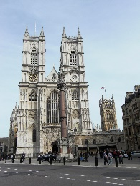
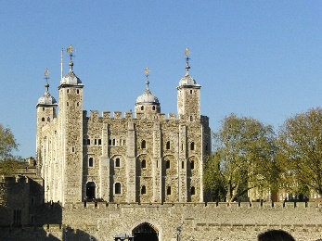 | 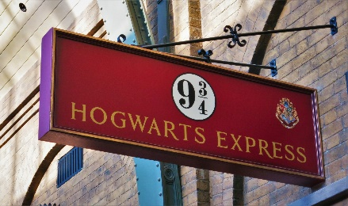 | 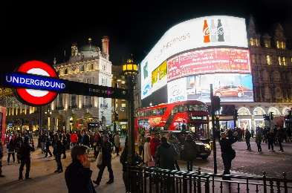
 | 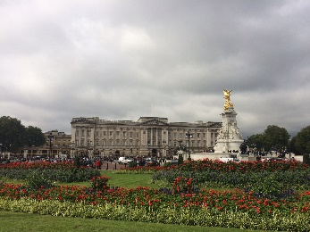

 Prima(r)Blog
Font: Abeezee
Bilder: Alle Bilder stammen von Pixabay und benötigen keine Lizenzangabe.

