
Reading Text for the sightseeing tour in TaskCards:
(Kein AB für die Kinder – nur zum Einlesen der Texte!)

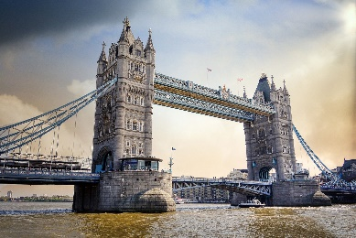 | We start our sightseeing tour through London at the famous Tower Bridge. The bridge crosses the river Thames. It can open in the middle. So ships can go under the bridge.  Our next stop will be the Tower of London.
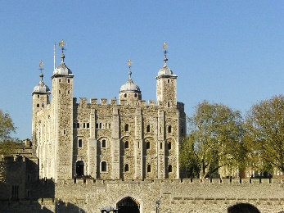 | Our stop No. 2 is the Tower. The Tower is a castle.  The Tower once was a prison for thieves and murderers. Today you can look at the crown jewels like the queens crown.  Next we are going to Piccadilly Circus.
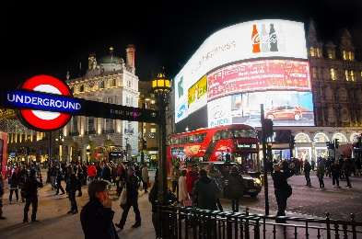 | We go shopping on stop No. 3: Piccadilly Circus. You can find some shopping centres here. There are restaurants and theatres, too.  Our next stop is a bit more relaxing. Go to Hyde Park.
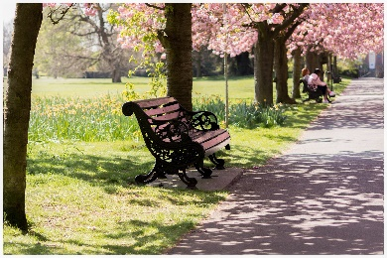 | Welcome to Hyde Park. When you need time to relax in London, here you can sit on a bench.  You can also row a boat on the lake here. But beware of the swans! All swans belong to the queen.  We go to Trafalgar Square next.
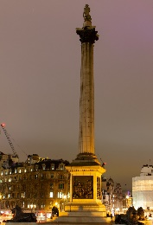 | The next stop is Nelson’s Column on Trafalgar Square. The monument is named after Admiral Nelson. There are four big lions around the column. People like to sit on the lions.  Please go to the Houses of Parliament now.
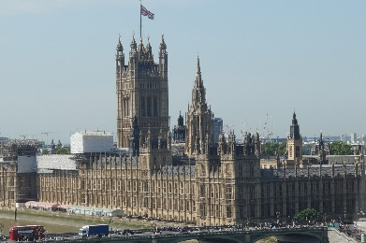 | Here we are at the Houses of Parliament. You can say “Westminster Palace”, too. Politics are made here.  And we are close to our next stop: Big Ben.
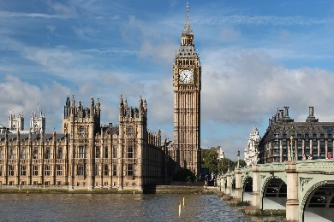 | Next to the Houses of Parliament we can see the famous Big Ben. In the clock tower, behind the clock, there is a big bell (ding, dong). The name of this bell is Big Ben. The melody it plays is famous (melody).  Please go to the London Eye next.
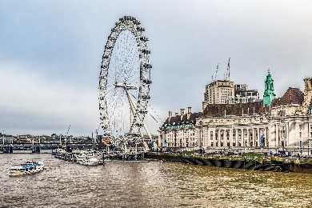 | By the river Thames you can take a ride on the London Eye. It is a giant wheel. People say “Eye”, because you can see so much of London from the wheel.  You can also see Westminster Abbey, our next stop.
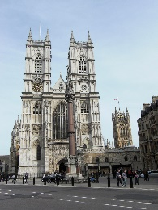 | Our next sight is Westminster Abbey. Here the queen got her crown. Royal weddings are held here. Prince William married Kate here. Princes and princesses are baptized here, too.  Let’s got to Wembley Stadium next.
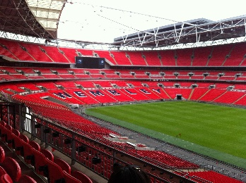 | Now we take a look at the Wembley Stadium, where Englands national team plays football and rugby.  Now we go back to Londons centre and visit The Shard.
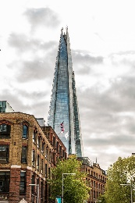 | The next stop is the very high skyscraper The Shard. There is a hotel in it and some restaurants and shops. And you can go to a viewing platform and look all over London.  Our next stop is Kings Cross Station.
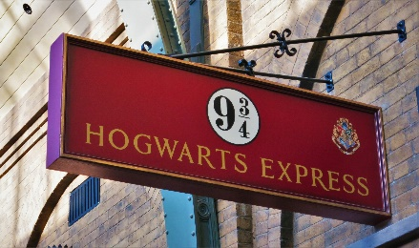 | The fans of Harry Potter visit Kings Cross station and platform 9¾. Kings Cross is a real train station. Platform 9¾ is only fiction, I’m sorry.  Now we go to our last stop: Buckingham Palace.
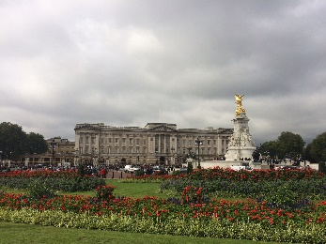 | The sightseeing tour ends at the queens home: Buckingham Palace. When the British flag, the Union Jack, is out, then the queen is at home. The Palace has a big garden. The Royal Guards guard the Palace day and night.  Now we have to stop our sightseeing tour. I hope you liked it! Thank you and goodbye!

Alle Bilder stammen von Pixabay und benötigen keine Lizenzangabe.

